**UNITED INSTITUTE OF TECHNOLOGY**

**(College Code:7145)**

**SERVERLESS IoT DATA PROCESSING**

**Team Members**

**Alex Baby D Bharath Kumar I**

**Karthika B Paul Rajan S**

**Praveen Karthick G Sharmila M**

**Mentor**

**Nishanthi - nishanthi@uit.ac.in**

**PROJECT DOCUMENTATION AND SUBMISSION**

**Title:**

**Severless IoT Data Processing**

**Abstract:**

In the era of IoT, the exponential growth of connected devices has presented new challenges for data processing and analytics. This paper explores the paradigm of serverless computing as a solution for efficiently handling IoT data. We discuss the advantages of serverless architecture, such as automatic scaling and cost optimization. Additionally, we present use cases and practical implementations of serverless IoT data processing, highlighting its flexibility and agility in adapting to changing workloads. The findings suggest that serverless computing holds great promise in addressing the evolving demands of IoT data processing, enabling organizations to extract valuable insights from their sensor data with reduced operational overhead.

**Introduction:**

Serverless IoT data processing involves leveraging cloud computing to handle and analyze the data generated by IoT devices without the need for managing servers. It allows you to focus on processing and extracting insights from the data while the underlying infrastructure is managed by the cloud provider. This approach offers scalability, cost-efficiency, and flexibility, as resources are provisioned and scaled automatically based on the workload. It enables real-time data processing, analytics, and integration with other services to drive meaningful actions and decision-making.

**Problem Statement:**

The Problem statement for Serverless IoT Data Processing is to create a home into a smart living space using IBM Cloud function for IoT data processing. The Goal is to collect data from smart devices like thermostats,motion sensors and cameras and process it in real-time.

**Objective:**

Create an efficient, responsive, and intelligent living space leveraging serverless IoT data processing to automate, analyze, and optimize various aspects such as energy usage, security, comfort, and convenience, ensuring a seamless, interconnected, and sustainable environment for residents.

**Design Thinking Refinement :**

1. **Smart Home Intelligence**:

Create a central "Smart Home Intelligence" platform powered by IBM Cloud Functions that acts as the brain of the smart home, managing all IoT data processing and automation.

1. **Real-Time Monitoring:**

Use cloud functions to process IoT data in real-time, allowing the system to react instantly to various triggers. For example, if a motion sensor detects movement at an odd hour, it can trigger alerts or specific actions.

1. **Energy Optimization:**

Implement algorithms that optimize energy consumption. For instance, the system can analyze energy usage patterns and automatically adjust lighting, heating, and cooling to reduce waste and lower utility bills.

1. **Customizable Automation:**

Offer homeowners the ability to create custom automation rules through a user-friendly interface. They can set up routines for specific scenarios, like "Good Morning" or "Movie Night," which can control various devices simultaneously.

1. **Predictive Maintenance:**

Use IoT data to predict maintenance needs for appliances. For instance, the system can monitor the health of devices and alert users when it's time for maintenance or replacement.

1. **Security and Access Control:**

Enhance home security by integrating cameras, door/window sensors, and access control systems. Cloud functions can process data from these devices and trigger security alerts or actions as needed.

1. **Voice and Gesture Control:**

Integrate voice and gesture recognition for hands-free control. IBM Cloud Functions can process voice commands and gestures, providing a convenient way to interact with the smart home.

1. **Data Insights and Reporting:**

Provide users with insights on their home's behavior. Cloud functions can generate reports on energy usage, security incidents, and device activity, helping homeowners make informed decisions.

1. **Weather Integration:**

Integrate weather data to adapt the home's automation to current conditions. For example, the system can adjust blinds and thermostats based on weather forecasts to optimize comfort and energy efficiency.

1. **Remote Accessibility:**

Develop a mobile app and web interface for remote control and monitoring. Users can access their smart home from anywhere, and IBM Cloud Functions ensures real-time updates and responsiveness.

1. **Privacy and Security:**

Implement robust security measures to protect sensitive data, and allow users to control data sharing and access permissions.

1. **Scalability:**

Ensure the system is easily scalable to accommodate more IoT devices and new features as technology advances.

1. **Continuous Improvement:**

Regularly update the system with new features and integrations, staying ahead of the curve in smart home technology.

**Development Phase:**

**1. Set Up IBM Cloud Account:**

If you haven't already, sign up for an IBM Cloud account and log in.

**2. Create an IoT Platform:**

* Go to the IBM Cloud Dashboard.
* Create an instance of the IBM IoT Platform service.
* Follow the setup instructions to configure your IoT platform

**3. Register Smart Devices:**

* Register your smart IoT devices within the IoT platform.
* You might need to generate authentication credentials or certificates for secure device communication.

**Code Snippet:**

**const Client = require('ibmiotf');**

**const deviceConfig = {**

**"org": "your-org-id",**

**"type": "your-device-type",**

**"id": "your-device-id",**

**"auth-method": "token",**

**"auth-token": "your-auth-token"**

**};**

**const deviceClient = new Client.IotfDevice(deviceConfig);**

**deviceClient.connect();**

**4. Set Up Data Collection:**

* Configure your devices to send data to the IoT platform using MQTT or HTTP.
* Define data formats, topics, and event triggers.



**Code Snippet:**

**deviceClient.on("connect", function () {**

**setInterval(function () {**

**const data = {**

**temperature: Math.random() * 100,**

**humidity: Math.random() * 100**

**};**

**deviceClient.publish("status", "json", JSON.stringify(data));**

**}, 5000); // Send data every 5 seconds**

**});**

**5. Set Up IBM Cloud Functions:**

* Create a new action within IBM Cloud Functions to process incoming IoT data.
* Write the code for data processing using Node.js, Python, or any supported language.

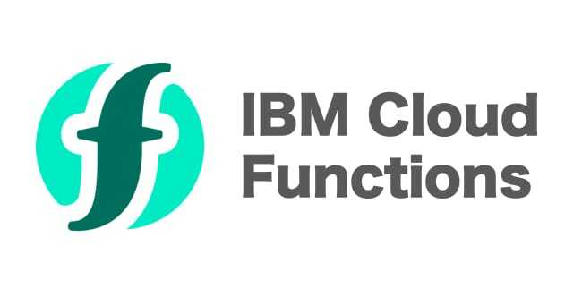

**Code Snippet:**

**function main(params) {**

**return { message: "Hello, IBM Cloud Functions!" };**

**}**

**6. Connect IoT Platform to IBM Cloud Functions:**

* Create a trigger that connects the IoT platform to your IBM Cloud Function.
* Specify the events or conditions that trigger the function

**7. Data Processing:**

* Inside your IBM Cloud Function, write the logic to process the incoming IoT data.
* You can perform data transformations, store data in databases, or trigger other actions.

**Code Snippet:**

**function main(params) {**

**const data = JSON.parse(params.payload);**

**// Perform data processing here**

**const result = { processedData: data.temperature * 2 };**

**return result;**

**}**

**8. Error Handling and Logging:**

Implement error handling and logging within your functions to monitor and troubleshoot issues.

**9. Testing:**

Test your setup by sending data from your smart devices to the IoT platform and ensuring the IBM Cloud Function processes it correctly.

**10. Scaling and Optimization:**

Depending on your requirements, optimize your serverless setup for scalability and cost-efficiency.

**11. Monitoring and Maintenance:**

* Implement monitoring tools to keep an eye on your IoT data processing solution.
* Regularly update and maintain your setup as needed.

**12. Security:**

* Ensure that data communication between devices and the IoT platform is secure.
* Implement access control and authentication measures.

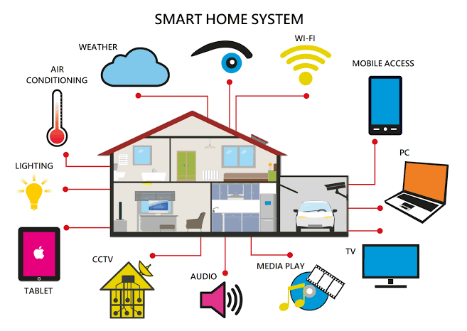

**SAMPLE CODE:**

here's a simplified sample code to give you an idea of how to set up an IBM Cloud Function to process IoT data. This example uses Node.js and assumes you've already set up the IoT platform and connected it to your function.

**Javascript**

**// Import required libraries**

**const request = require('request-promise');**

**const { apiKey, iotPlatformEndpoint } = process.env;**

**// Define the IBM Cloud Function**

**function processIoTData(params) {**

**// Extract data from the IoT message**

**const deviceData = params.payload;**

**// Perform your data processing here**

**const processedData = processData(deviceData);**

**// Example: Send the processed data to an external service**

**sendToExternalService(processedData);**

**return { message: 'Data processed successfully' };**

**}**

**function processData(data) {**

**// Implement your data processing logic here**

**// For example, data transformations, filtering, or calculations**

**// Return the processed data**

**return data;**

**}**

**function sendToExternalService(data) {**

**// You can send the data to an external service or storage here**

**// Example: Send data to a database or another API**

**// Use request-promise or other libraries to make HTTP requests**

**const options = {**

**uri: 'https://api.example.com/data',**

**method: 'POST',**

**body: data,**

**json: true,**

**};**

**return request(options);**

**}**

**// Main function handler**

**exports.main = processIoTData;**

**In this code:**

1. We import the required libraries, including `request-promise` for making HTTP requests.

2. The `processIoTData` function is the main handler for the IBM Cloud Function. It processes the incoming IoT data and sends the processed data to an external service.

3. The `processData` function is a placeholder for your custom data processing logic. You can implement any data transformations or calculations needed.

4. The `sendToExternalService` function demonstrates how to send the processed data to an external service or API. You should customize this part to match your specific use case.

Remember to configure environment variables for your IBM Cloud Function (e.g., `apiKey` and `iotPlatformEndpoint`) and connect the function to your IoT platform trigger, so it gets executed when IoT data arrives.

**Implementation Overview of Serverless IoT Data Processing in a Smart Living Space**

**Smart Home Setup:**

A smart home setup typically involves integrating various devices like smart thermostats, lights, security cameras, and more. Technical implementation can vary, but generally, it involves a central hub or platform that connects these devices, often via Wi-Fi or Bluetooth.

**Real-time Data Processing:**

Real-time data processing in a smart home involves collecting information from sensors or devices and processing it instantly. This might include analyzing temperature changes, motion detection, or energy consumption, often using edge computing or cloud services to process this data in real-time.

**Automation Routines:**

Automation routines are set up through platforms or apps that allow users to create scenarios or triggers, like turning off lights when no motion is detected or adjusting the thermostat based on a schedule or environmental factors.

**Data Storage:**

Data storage on IBM Cloud for a smart living space typically involves using their cloud services to securely store the collected data from various devices. This data might be stored in databases or object storage for further analysis or historical tracking.

**Conclusion:**

By leveraging IBM Cloud Functions for serverless IoT data processing, this smart home concept can provide an intelligent, secure, and energy-efficient living environment that adapts to the needs and preferences of its residents while continuously evolving to embrace new technologies and capabilities.